SOLUTIONS

See completed page

http://peterfaulks.net/Teaching/Student_Compendium/SC040_War.htm

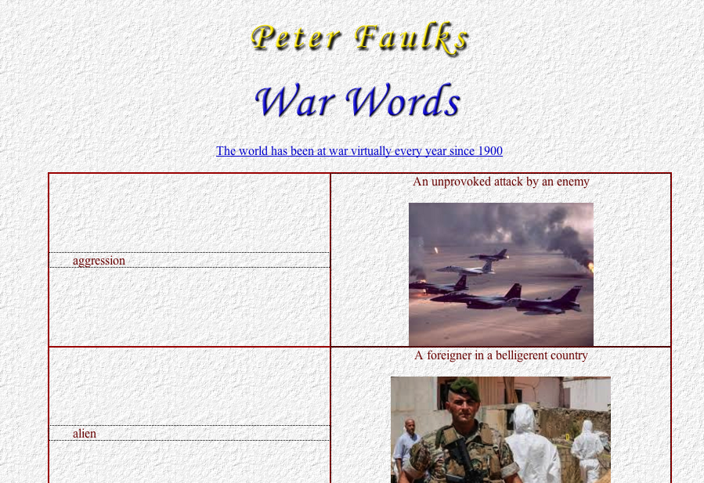

War Words

An unprovoked attack by an enemy | aggression
A foreigner in a belligerent country | alien
Shells, bombs, military stores | ammunition
A general pardon of offenders | amnesty
To reduce to nothing | annihilate
An agreement by belligerents to stop fighting | armistice
A place where naval or military weapons are made or stored | arsenal
A broad belt worn by cadets across the right shoulder and across the chest with pockets for carrying cartridges | bandolier
The main division of an army | battalion
A short sword fixed on to the end of a gun | bayonet
Nations carrying on warfare | belligerents
To surround a place with the intention of capturing it | besiege
An encampment in the open air | bivouac
To camp in the open air without tents or covering | bivouac
Official reports on the progress of the War | bulletin
A place where soldiers can buy drinks and other refreshments | canteen
To surrender to an enemy on agreed terms | capitulate
The killed or wounded in battle | casualties
Horse-soldiers | cavalry
To seize for military use | commandeer
A person who is forced by law to become a soldier | conscript
Compulsory enrolment as soldiers or sailors | conscription
Smuggling of goods or engaging in prohibited traffic | contraband
A number of ships travelling together under escort for the sake of safety | convoy
To release from the army | demobilise
The art of conducting negotiations between nations | diplomacy
An order prohibiting ships to leave the ports | embargo
The act or practice of spying | espionage
To remove from one place to another to avoid the destruction of war | evacuate
A soldier's holiday | furlough
A number of firearms being discharged continuously | fusillade
A body of soldiers stationed in a fortress to defend it | garrison
A fortified place defended by soldiers, cannons, etc. | garrison
An irregular warfare conducted by scattered or independent bands | guerilla-war
Foot-soldiers | infantry
To keep citizens of another country in confinement | intern
To enter a country as an enemy | invade
Skilful movement of ships or troops in order to secure an advantage over the enemy | manoeuvre
To make troops, ships etc. ready for war service | mobilize
Taking neither side in the struggle, that is, not assisting either of the belligerents | neutral
Heavy guns, artillery and army stores | ordnance
An apparatus which opens like an umbrella to enable a person to drop safely from an aircraft | parachute
A promise given by a prisoner not to try to escape if given temporary release | parole
A long strip of cloth bound round the foot of soldiers from the ankle to the knee | puttees
To make an examination or preliminary survey of enemy territory or military objective | reconnoiter
A soldier recently enlisted for service | recruit
Music for awakening soldiers in the morning | reveille
The firing of many guns at the same time to mark an occasion | salvo
A shower of bullets | volley

Reveille, from the French word ‘reveillez’, meaning to ‘wake-up’, was originally played as a drum beat just prior to daybreak.
Its purpose is to wake up the sleeping soldiers and to let the sentries know that they could cease challenging. It was also a signal to open the town gates and let out the horse guard, allowing them to do a reconnaissance of the immediate area beyond the walls.



